Biodiversity Conservation Trust

Expression of Interest Form
  - Restoring Murray Woodlands Biodiversity and Carbon Conservation Tender
  - | January 2023

Restoring Murray Woodlands Biodiversity and Carbon Conservation Tender
The Biodiversity Conservation Trust is inviting expressions of interest (EOIs) to participate in a biodiversity and carbon conservation tender, which if successful would require registering an environmental plantings pilot carbon project under the Emissions Reduction Fund (also known as the Australian Carbon Credit Unit Scheme). Successful tenderers would secure a permanent conservation agreement over remnant vegetation on their land and the environmental plantings carbon project area.
This tender is targeting remnant patches of three threatened ecological communities: Inland Grey Box Woodland, Sandhill Pine Woodland and White Box-Yellow Box-Blakely’s Red Gum Grassy Woodland and Derived Native Grassland and can include other native vegetation and adjoining areas for revegetation within eligible areas in the below map. EOIs must be submitted by 11:59pm on 6 March 2023 to be eligible for consideration.
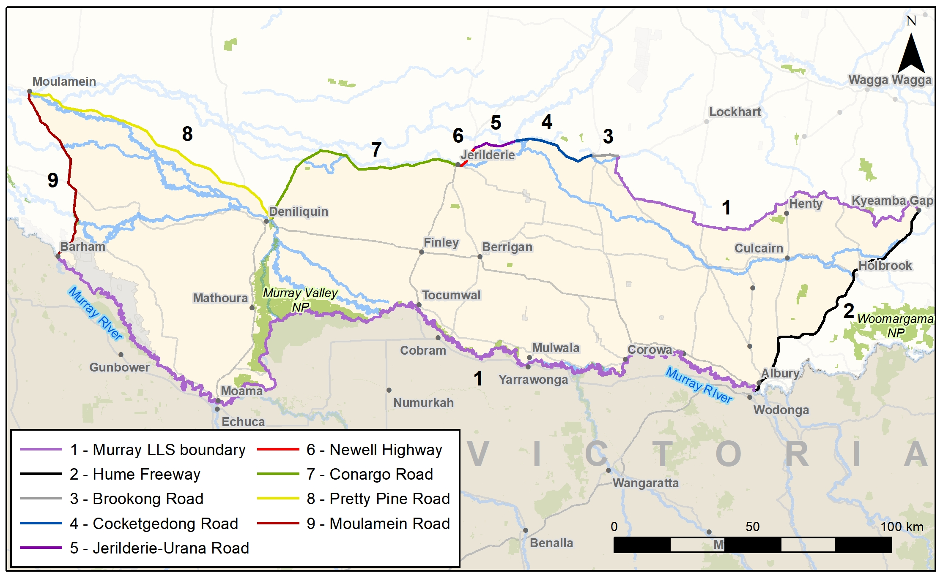

Figure 1: Map of NSW showing the area of eligibility for this tender. To participate, your property must be within this area.

Important information for landholders
Submitting an Expression of Interest (EOI) is the first step to take if you are interested in participating in a BCT conservation tender. See below for where to submit your EOI.
The BCT will undertake a desktop assessment to ensure that your site is located within the tender area and meets the minimum size requirements. EOIs may then be prioritised with the highest-ranking sites offered a site assessment. If your site is ineligible to participate in the tender, the BCT will contact you to discuss alternate options that you may wish to consider.
If you make an EOI over the phone, and you are eligible for a site assessment, a BCT field officer will bring a record of the EOI to the site visit, and you will be asked to confirm the details.
Registration of an EOI does not mean that you are required to submit a bid, however, it ensures that your site will be assessed for eligibility.
The BCT reserves the right to extend the EOI period or close the EOI period early if a sufficient number of applications are received.
Please consult the Restoring Murray Woodlands Landholder Guide available on the BCT website for rules on eligible sites and entities. It is recommended that you attend an information session or watch the recording on our website (ref for info sessions)
Please complete the information requested as accurately as possible and contact the BCT if you require assistance filling out this form.
For more information about the Conservation Tender you can call the Murray Riverina regional team on 1300 992 688 or visit the BCT website at www.bct.nsw.gov.au.

Lodging your Expression of Interest Form

Send a completed EOI form via info@bct.nsw.gov.au or call the BCT on 1300 992 688 to lodge your interest.
Emailed EOIs are strongly preferred.
If email is not possible an EOI form can be posted to:
NSW Biodiversity Conservation Trust
Private Locked Bag 5023
PARRAMATTA NSW 2124

Landholder,(s) full names
This must be one of the persons on title.

ABN/ACN

Property address

Postal address (if different from property address)

Contact phone numbers

Email address

Local Government Area

Approximate Property Size (ha)

Lot and DP numbers of property
(as shown on a Council Rates Notice)

Property number
You can find your property number:
- on your Notice of Valuation.
- on your land tax assessment from Revenue NSW.
- by conducting a title reference enquiry if you know your title reference.
- by conducting a property address enquiry if you know your property address.
Proposed conservation area size (ha)  Please provide your best estimate of:  - the hectares of vegetation to be included in the conservation area; and  - the hectares for revegetation under the environmental plantings carbon project (5ha min and 50ha max) | __ ha size of remnant area  __ ha size of revegetation area  --
Lot and DP numbers of proposed conservation area
(as shown on a Council Rates Notice)
Is your property freehold land?
Leasehold land is not eligible for this tender.
Preferred method and time of contact?
e.g., mobile, landline, during work hours, weekends.
How did you hear about us?

Contact and property details
Do any of the following agreements apply to the proposed conservation area:
Conservation Agreement under National Parks and Wildlife Act 1974 Yes   No  
Conservation Agreement under the Biodiversity Conservation Act 2016 Yes   No  
Biodiversity Stewardship Agreement under the Biodiversity Conservation Act 2016 Yes   No  
Trust Agreement under Nature Conservation Trust Act 2001 Yes   No  
Registered Property Agreement under the Native Vegetation Conservation Act 1997 Yes   No  
Property Vegetation Plan or an offset or set-aside requirement Yes   No  
Carbon agreement or a private native forestry agreement Yes   No  
Catchment Management Authority or Local Land Services Management Agreement Yes   No  
Do you have other covenants, caveats, agreements or restrictions on title Yes   No  

If you have answered yes to any of the above, please provide name of the Agreement/requirement and the Agreement reference number:

What types of activity would you like to continue in the conservation area?
Please describe future land use.

Are you interested in regular updates from the BCT on other programs and opportunities?
If so, tick yes below to be added to a BCT distribution list to receive updates and e-newsletters in the future.
  Yes   No

………………………………….  Landholder Signature | …………………………………  Landholder (Print) | ………………………………….  Date
………………………………….  Landholder Signature | …………………………………  Landholder (Print) | ………………………………….  Date

In signing this EOI form I confirm that I am the owner of the land in question and that I am an Australian citizen.
I also confirm that I am not a close family member of any BCT staff or BCT Board member or contractor engaged by the BCT.

How your information will be managed
Information received in an Expression of Interest or an application is treated as confidential. However, documents held by the BCT are subject to the Government Information (Public Access) Act 2009 (NSW) (GIPA Act). This means that the information contained in this form may be released in response to an application lodged under the GIPA Act.
The BCT is committed to protecting the privacy of your personal information, in accordance with the Privacy and Personal Information Protection Act 1998 (NSW). Personal information provided on this form is collected for the purpose of administering the BCT’s Conservation Management Program, and consideration of your eligibility for the BCT’s other programs and future opportunities. The BCT will not use it for any other purpose, nor will it be disclosed, unless with your consent or in other circumstances where such use or disclosure is permitted under the Privacy and Personal Information Protection Act 1998. You may choose not to provide your personal information to BCT. However, this may mean that it is not possible for the BCT to assess your Expression of Interest. For information about how your personal information is collected, used and disclosed by the BCT, please see the privacy policy available at http://www.environment.nsw.gov.au/whoweare/privacy.htm. You can ask to access or amend your personal information held by the BCT by contacting:
NSW Biodiversity Conservation Trust
General mail: Locked Bag 5022 Email: info@bct.nsw.gov.au
Tender mail: Private Locked Bag 5023 Phone: 1300 992 688.
Parramatta, NSW 2124

Section 1.6(1) of the Biodiversity Conservation Act 2016 defines a landholder to mean a person who is the owner of land or who, whether by reason of ownership or otherwise, is in lawful occupation or possession, or has lawful management or control, of land.
Section 1.6(1) of the Biodiversity Conservation Act 2016 defines an owner of land to include: (a) every person who, either at law or in equity: (i) is entitled to the land for any estate of freehold in possession, or (ii) is a person to whom the Crown has lawfully contracted to sell the land under the _{Crown Land Management Act 2016} or any other Act relating to the alienation of lands of the Crown, or (iii) is entitled to receive, or is in receipt of, or if the land were let to a tenant would be entitled to receive, the rents and profits in respect of the land, whether as beneficial owner, trustee, mortgagee in possession or otherwise, and (b) a person who leases land under the Crown Land Management Act 2016, and (c) any other person who, under the regulations, is taken to be the owner of the land, but (unless the regulations otherwise provide) does not include a beneficiary of a trust relating to the land.

